**Capstone Project**

**Document Template**

Note: The following are the candidate sections of the document. They are presented here for guidance. Questions in each section could be used as possible aspects to cover. Some questions may not be applied to each project. On the other hand, additional information may be needed.

# Introduction

## Purpose

**What is the problem or the opportunity that the project is investigating?**

The RentShare application addresses the issue of underutilised belongings and the limited options for people to access items temporarily. RentShare bridges the gap between individuals who have items they are willing to rent out and those who need access to items for a short period while providing an avenue for users to make a small income from the belongings they rent out.

**Why is this problem valuable to address?**

The opportunity lies in creating a platform where users can easily rent and borrow items with others in the community, promoting a more sustainable and economical lifestyle. RentShare aims to minimise the need for excess consumption, fast fashion and the ever-growing throwaway culture by encouraging a collaborative approach to accessing items.

RentShare contributes to minimising unnecessary production and consumption through the sharing of resources, reducing the overall environmental impact associated with manufacturing and disposal.

**What is the current state (e.g. unsatisfied users, lost revenue)?**

In my experience, people tend to let their unused belongings stay unused or end up in the trash proving that the current state is undesirable.

**What is the desired state?**

The desired state is to provide an easy, streamlined, secure way for individuals to rent out/ rent items within New Zealand.

**Has this problem been addressed by other projects? What were the outcomes?**

Currently, in New Zealand, there is only one online rent/share platform (La’Rent) that allows for used to rent items from many categories. I believe that another option for New Zealanders to rent their belongings would be beneficial for creating a more dynamic and competitive marketplace, offering users greater choice and flexibility for the unique needs of our community.

The current options website is difficult to find, has a small social media presence and allows users to post items for rent that are in countries other than New Zealand. RentShare aims for SEO to be a top priority so that users can easily access the application. RentShare will be purely New Zealand based so that the application is not clogged up with inaccessible items from around the world.

## Industry/ domain

**What is the industry/ domain?**

Peer-to-peer sharing economy

**What is the current state of this industry? (e.g. challenges from startups)**

The peer-to-peer sharing economy has been rapidly growing in NZ and globally with platforms such as Trade-me, Facebook marketplace and Airbnb all taking off in New Zealand. These well-known platforms focus on selling and buying equipment. Start-ups in this industry face challenges with market saturation, trust and differentiation.

As RentShare focuses on the renting of equipment, the market saturation is low. This also creates a point of differentiation for my application. The eventual social media integration will create a layer of trust between users and the application.

**What is the overall industry value chain?**

1. Marketplace creation
2. Gain users
3. User interaction
4. Financial transactions
5. Item pickup/delivery

**What are the key concepts in the industry?**

Peer-to-peer sharing – exchange of goods between individuals

Collaborative consumption – sharing access to goods, reducing the demand for production

Reputational systems – such as ratings, help build and maintain trust among users

Ownership – ensuring the owner of the item remains the owner

**Is the project relevant to other industries?**

Yes, the project is relevant to all the industries in which the items are, i.e., tools, clothes, books, farm equipment, health and fitness, books, art, sport and recreation etc.

RentShare is also relevant to the retail/e-commerce industry as it relies heavily on a consumption market.

## Stakeholders

**Who are the stakeholders? (be as specific as possible as to who would have access to the software) And why do they care about this software?**

Lenders – They care because RentShare provides users with a way to make an income from their underused items.

Borrowers - They care because it provides a way to access items without the long-term and financial commitment of ownership

**What are the stakeholders’ expectations?**

Lenders – expect a reliable way to safely earn an income through lending their belongings.

Borrowers – expect access to a variety of items in good condition. They expect ease of use and cost transparency

# Product Description

## Architecture Diagram

Include a diagram of the building blocks of the design including users and how they interact with the product.

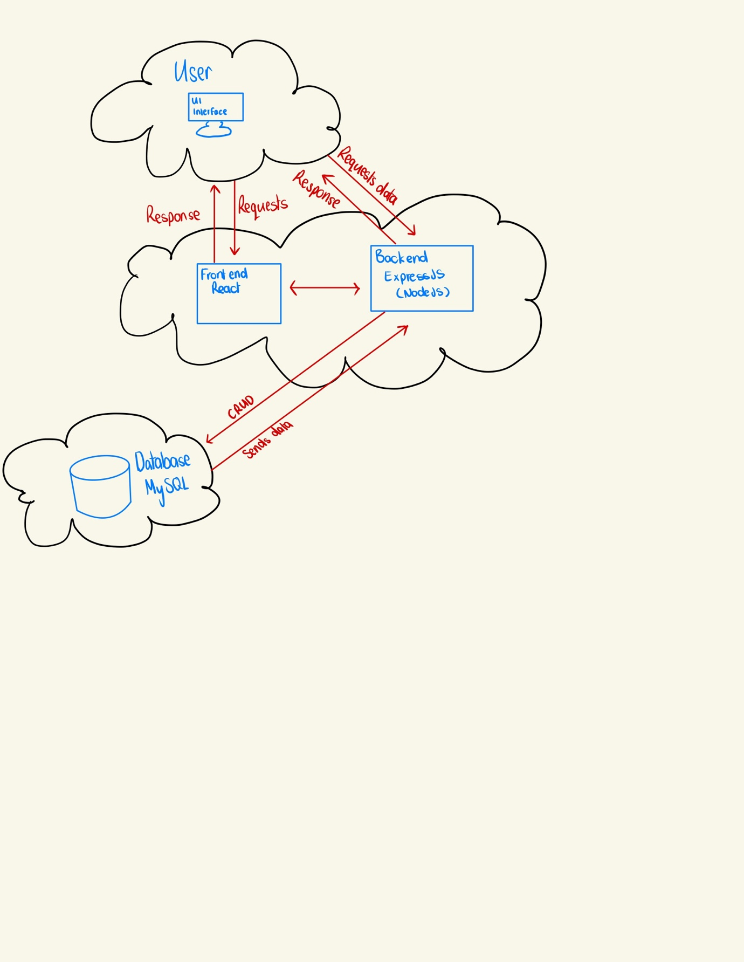

## User Stories

|  |  |  |  |  |
| --- | --- | --- | --- | --- |
| # | User Story Title | User Story Description | Priority | Additional Notes |
| 1 | Account creation and log in | As a user I want to be able to create an account and then sign in with my newly created account | High |  |
| 2 | Finding items | As a user I want to be able to see what items are available. I want to be able to filter based on my requirements | High | Search, category, and price filtering |
| 3 | Hiring items | As a user I want to be able to hire items from my timeline | High |  |
| 4 | Messaging | As a user I want to be able to message users | High |  |
| 5 | Creating a post | As a user I want to be able to create an item to rent | High |  |
| 6 | Saving items | As a user I want to be able to save items that I may want to hire later | Medium |  |
|  |  |  |  |  |

## User Flow

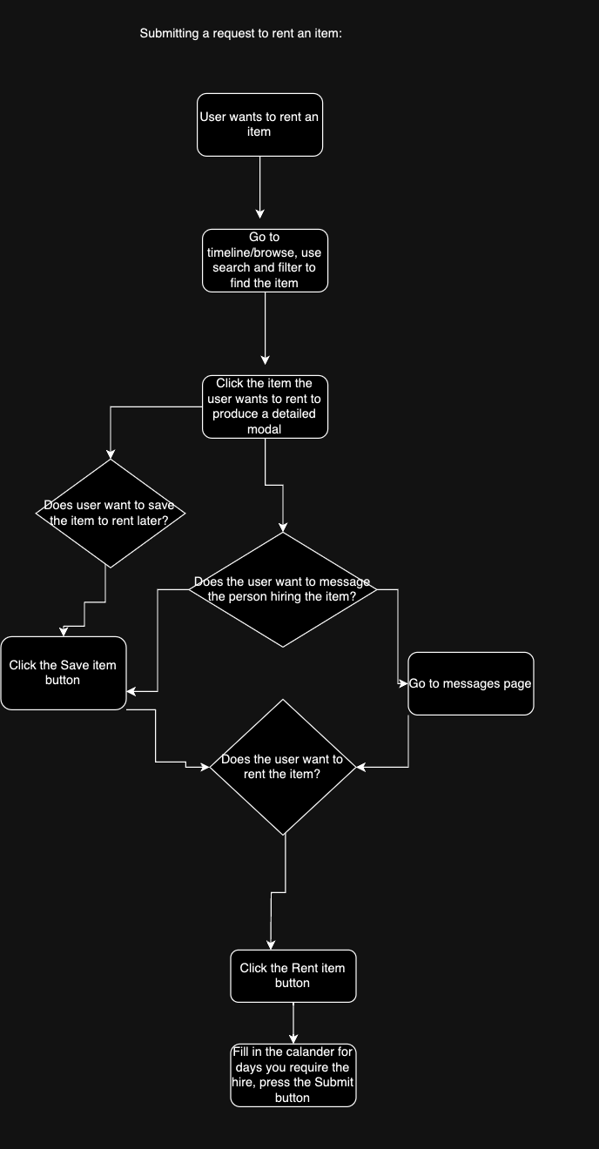

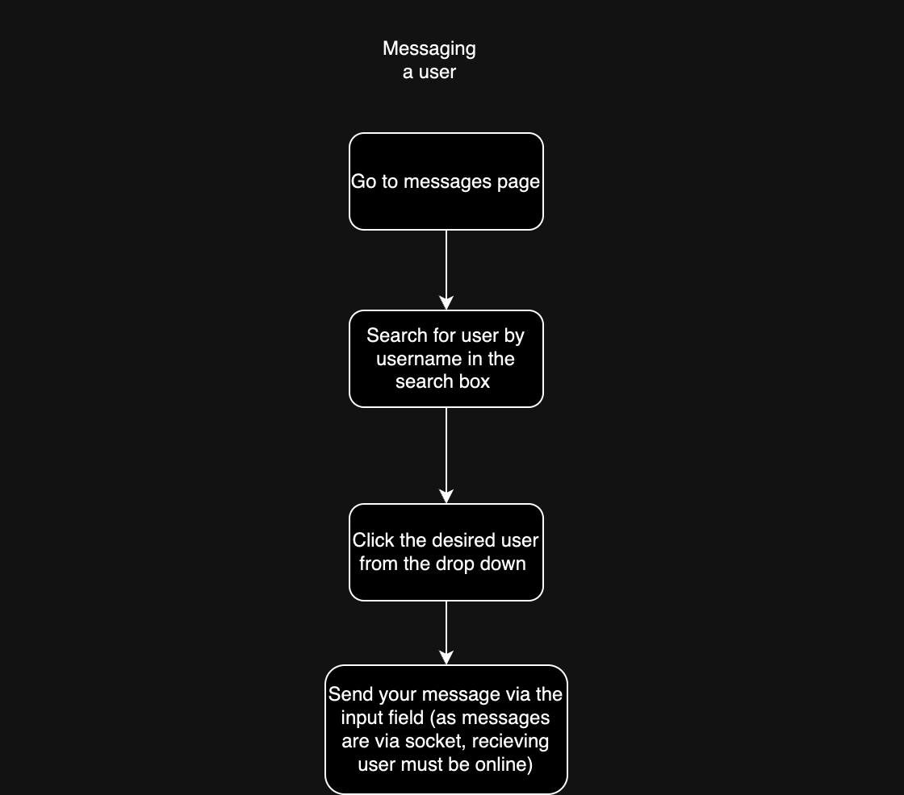

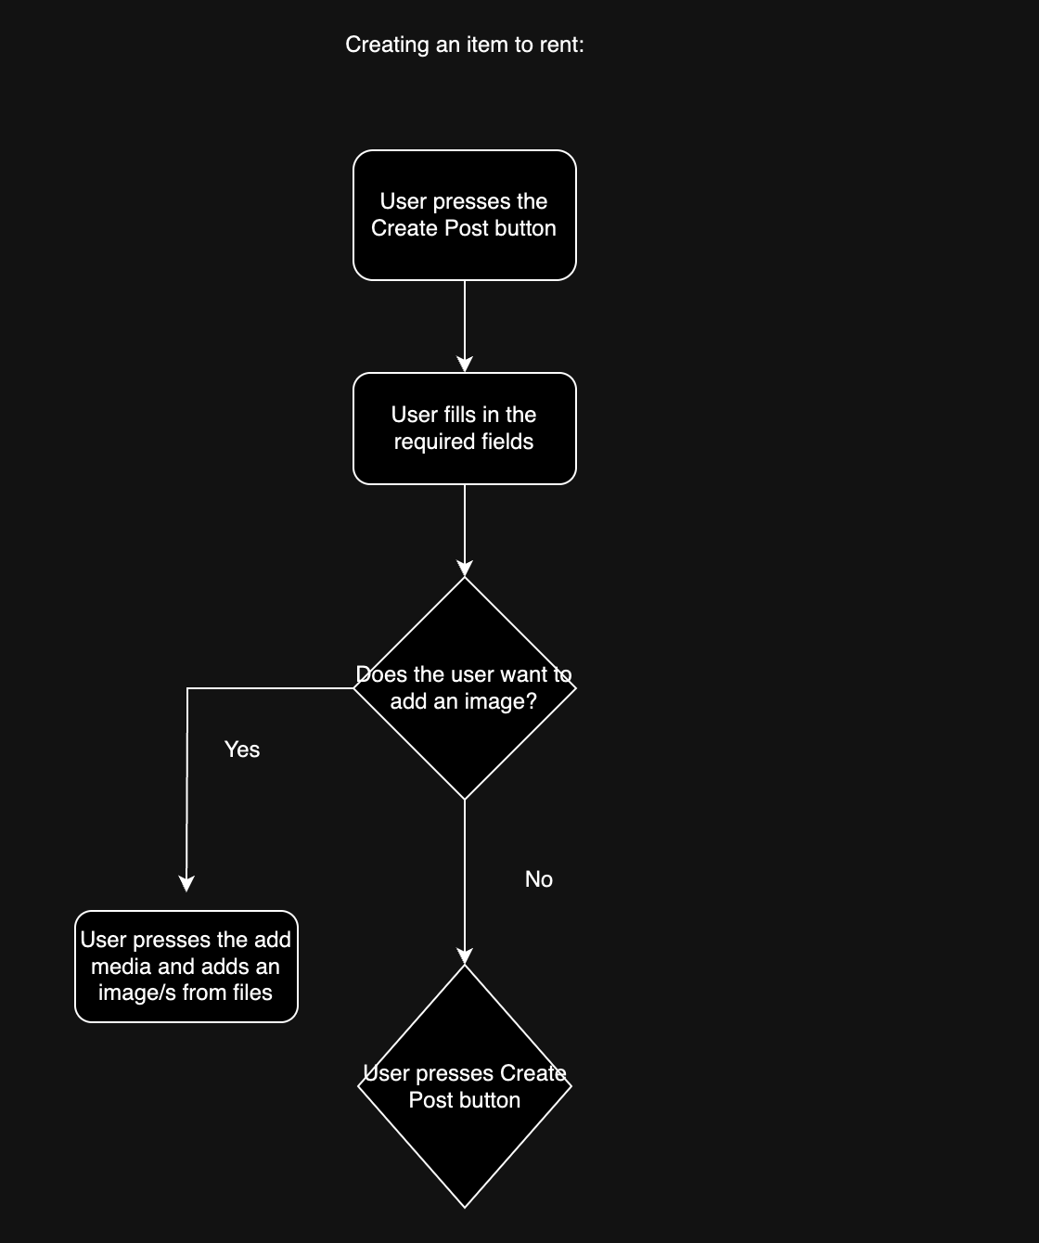

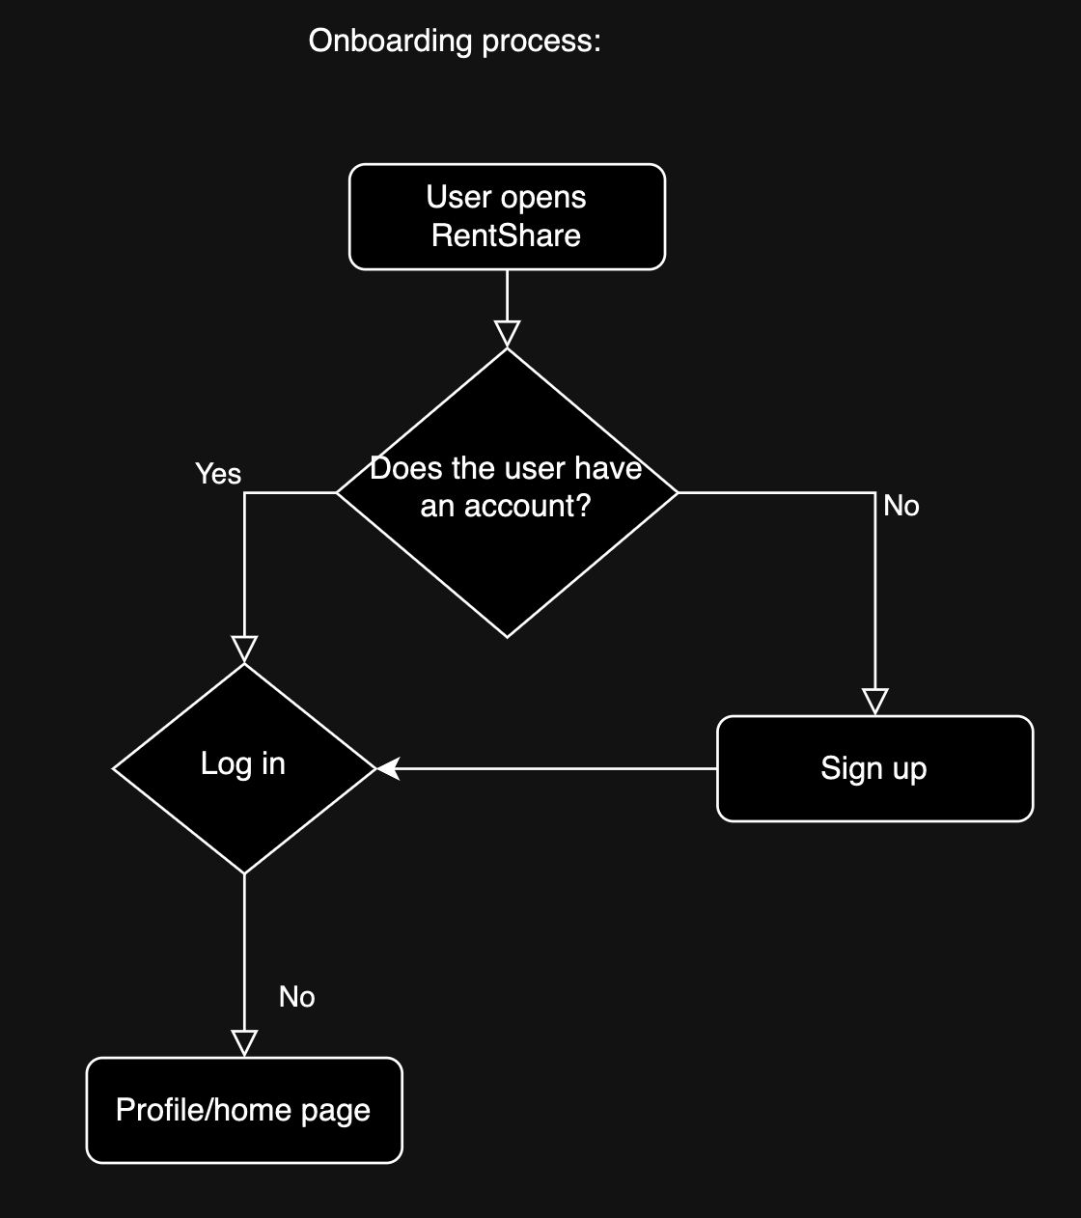

## Wireframe Design

Lo-Fi design:  
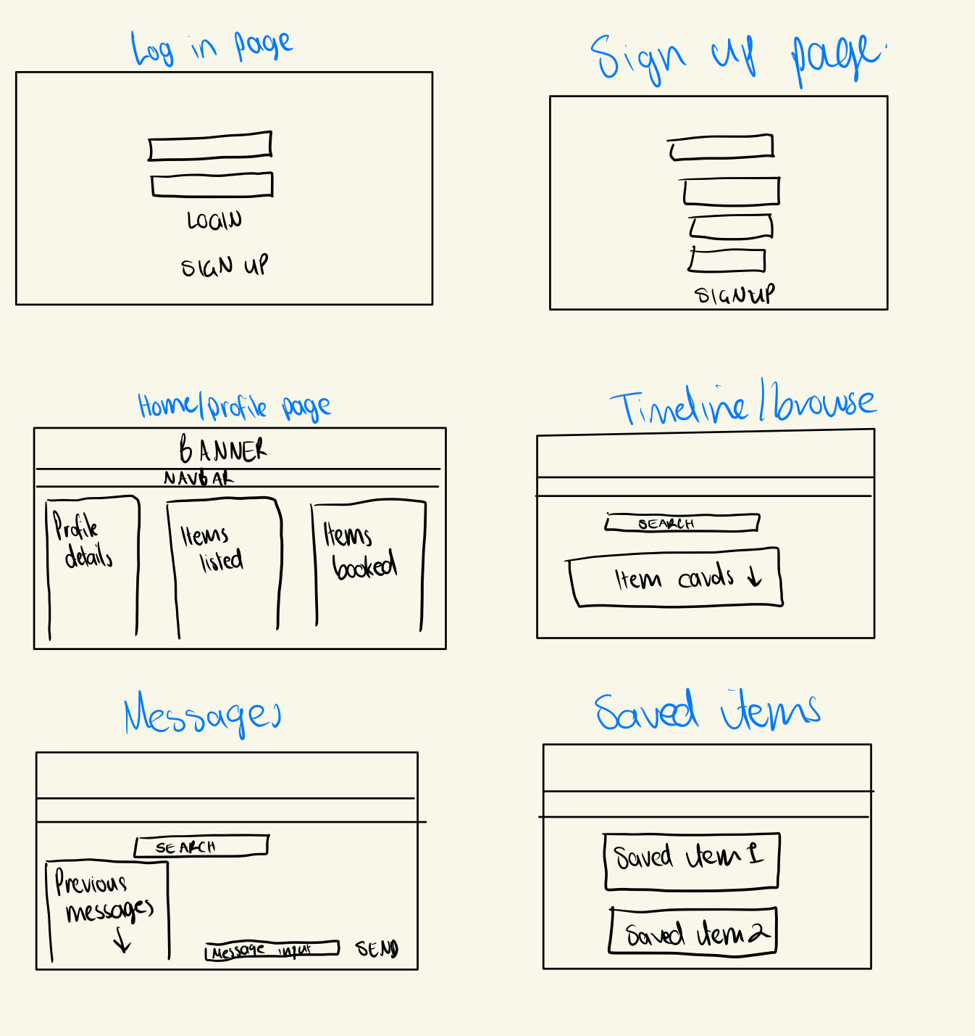

Hi-Fi Prototype Figma link:  
<https://www.figma.com/file/pQWsJ4r8t0SQUk9rsIcBvo/Capstone-Project?type=design&node-id=0-1&mode=design&t=yhT7EhrM7XyIe31C-0>

## Open Questions/Out of Scope

* Encryption/HTTPS
* Notifications
* Accept/ decline bookings
* Full chat with notifications, and messaging users that are not online

## Non-functional Requirements

**What are the key security requirements? (e.g. login, storage of personal details, inactivity timeout, data encryption)**

* + Login – user must sign up and login with email and password to access the application
  + Storage of personal details – personal details are stored in the database, passwords encrypted by bcrypt

**How many transactions should be enabled at peak time?**

* + Would need to do load testing and performance testing to determine this. Depends on how many users would be using the application

**How easy to use does the software need to be?**

* + Easy enough for any one with any level of technology skill can use

**How quickly should the application respond to user requests?**

* + As quickly as possible for seamless user experience

**How reliable must the application be? (e.g. mean time between failures)**

* + As reliable as possible, more failures = loss of revenue for users and application owners

**Does the software conform to any technical standards to ease maintainability?**

* + Backend – uses MVC structure
  + Front end – components are reused

# Project Planning

Include a Gantt chart or screenshot of a Trello board showing key milestones (with dates) to complete the project.

|  |  |  |  |  |  |  |
| --- | --- | --- | --- | --- | --- | --- |
| Monday | Tuesday | Wednesday | Thursday | Friday | Saturday | Sunday |
|  |  |  |  |  | 16  Planning + documentation | 17  Sketches (Lo-Fi) |
| 18  Logical & Physical models – choose RDMS | 19  Start front-end | 20  Components  Log in form  Signup form  Profile info | 21  Components  Item cards | 22  Components  Create post  Browse | 23 | 24  Start database and back end |
| 25 | 26 | 27  Back-end models | 28  Back-end controllers | 29  Link front-end to back-end | 30  All CRUD operations working | 31  Search functionalities |
| 1 | 2 | 3 | 4  Messaging | 5 | 6 | 7  Have messaging finished |
| 8  Styling | 9  Styling done | 10 | 11  Tidy code | 12  Comment code | 13  Comment code | 14  documentation |
| 15  Fix any bugs | 16  AWS | 17  AWS | 18  Work on your presentation | 19  Finish your presentation | 20  **Present** |  |

# Testing Strategy

* Thunderclient used to test CRUD operations of databse
* Every component was tested in a new branch on Github, any bugs fixed, before merging with the main branch
* Profile info and itemcards components were tested with dummy data before integrating to the database
* Tested the whole application as a user by a third party “tester” (my dad) to ensure there were no unexpected failures or difficulty to use
* Code was commented to ensure understanding when reading the code
* Console.logs and the browser inspect were used to find any edge cases

# 

# Implementation

**What were the considerations for deploying the software?**

The software was not deployed on AWS so can only be run locally

When I do deploy on AWS I will use EC2 and RDS to deploy the application

# End-to-end solution

**How well did the software meet its objectives?**

* The software is functional and met its requirements for this project

# References

**Where is the code used in the project? (link to GitHub)**

<https://github.com/LilyBarrettPower/capstoneProject.git>

**What are the resources used in the project? (libraries, APIs, databases, tools, etc)**

* GitHub
* MySQL
* React
* NodeJS/Express